LAB #10

To study introduction to UML, developing SRS using Use case diagram.

UML Introduction
- UML = Unified Modeling Language
- A standard language for specifying, visualizing, constructing, and documenting software artifacts
- Standardized by Object Management Group (OMG)
- Uses mostly graphical notations
- Helps project teams communicate, explore potential designs, and validate the requirements and architectural design of the software system
Use-case Diagram
Use case diagrams comprise of −

- Use cases
- Actors
- Relationships like dependency, generalization, and association
- Use case diagrams give an outsider’s view of a system.
- Every use-case diagram has actors, use cases, and communication
- A simple use case diagram can be expanded with additional features to display more information
- A system boundary rectangle separates the clinical system from the external actors.
- A use case generalization shows that one use case is simply a special kind of another. Pay bill is parent and bill insurance is the child.
- Include relationships factor use case into additional ones.
- An extend relationship indicates that one use case is variation of another
USE CASE

A use case describes the actions of a system performs yielding visible results. It shows the interaction of things outside the system with the system itself. Use cases may be applied to the whole system as well as a part of the system.

ACTOR

An actor represents the roles that the users of the use cases play. An actor may be a person (e.g. student, customer), a device (e.g. workstation), or another system (e.g. bank, institution).
The following figure shows the notations of an actor named Student and a use case called Generate Performance Report.
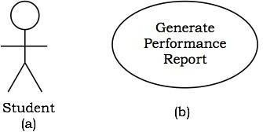
Cancel Appointment
Make Appointment
Check Patient Record
Request Medication
Defer Payment
Pay Bill
Extension Points
More Treatment

Bill Insurance
<<include>>
<<include>>
<<extend>>
generalization
Clinic
Patient
Scheduler
Doctor
Clerk

Example Use Case:
Let us consider an Automated Trading House System. We assume the following features of the system −

  - The trading house has transactions with two types of customers, individual customers and corporate customers.

  - Once the customer places an order, it is processed by the sales department and the customer is given the bill.

  - The system allows the manager to manage customer accounts and answer any queries posted by the customer.

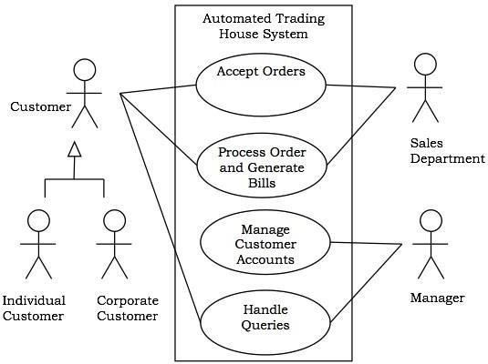

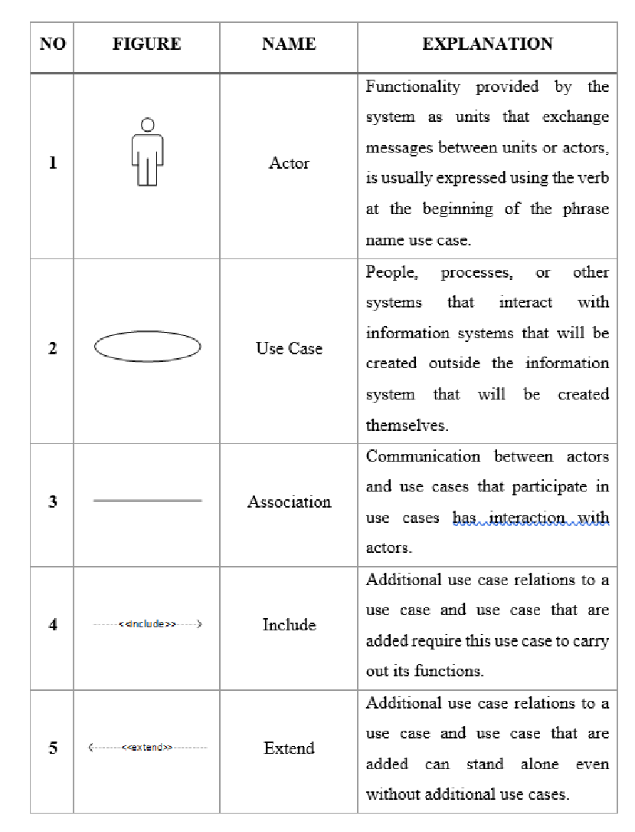

TASK
Draw use case diagram for following case study.

Library Management System
Problem Statement:
The case study titled Library Management System is library management software for the purpose of monitoring and controlling the transactions in a library. This case study on the library management system gives us the complete information about the library and the daily transactions done in a Library. We need to maintain the record of new s and retrieve the details of books available in the library which mainly focuses on basic operations in a library like adding new member, new books, and up new information, searching books and members and facility to borrow and return books. It features a familiar and well thought-out, an attractive user interface, combined with strong searching, insertion and reporting capabilities. The report generation facility of library system helps to get a good idea of which are ths borrowed by the members, makes users possible to generate hard copy.
The following are the brief description on the functions achieved through this case study:
End-Users:
•Librarian: To maintain and update the records and also to cater the needs of the users.
•Reader: Need books to read and also places various requests to the librarian.
•Vendor: To provide and meet the requirement of the prescribed books.

